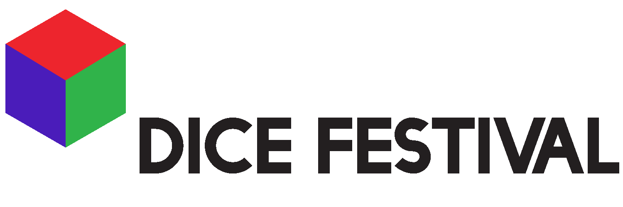
OPEN CALL

BE PART OF DICE FESTIVAL AT CAMDEN PEOPLE’S THEATRE 2018.

6/7 OCTOBER

WHO WE ARE:

DICE Festival is an artist-led festival of chance, programming live art and experimental performance from artists of all backgrounds and at every stage in their career. We are currently looking for some brilliant stuff to programme. The only parameters for anything that we programme, is that it can be shown in 15 minutes or less. If you have a performance, an action or an extract from a show that you think could work for DICE, and you want to play DICE with us, send us your application... we want to hear from you!

Deadline: 21st September 2018

HOW TO PLAY
(Here are the rules):

1. On each night, there are six acts.
2. When, and if, each act will perform, will be determined by the roll of a die.
3. The rolling of the die will be completed by the evenings host, the Dice Master.
4. The die will be rolled six times.
5. Each act risks performing six times, and not performing at all.
6. We like the number six.

WHAT WE CAN OFFER:

:: Artist’s fee of £100 ::

:: A home-cooked meal the night you’re programmed ::

:: A supportive and engaged environment to share your work ::

:: Basic technical support ::

:: Photographic and video documentation ::

:: A chance to meet other artists and be a part of our growing community ::

Here are 6 important things we want you to know about us, before you decide to play:

WE WANT to value you as an artist. This is a paid opportunity. Whether your number is rolled 6 times, or if you don’t get rolled at all, all artists will be paid the same, fixed fee. And if your number does not get rolled, you will be invited to take part again the next time we play.

WE WANT to pose a provocation of what it means to be making art under a capitalist paradigm. We want to displace and question the structure of choice within live performance.

WE WANT to see what happens when unexpected elements place themselves beside one another.

WE WANT to create a dialogue between artists and audiences. We want everybody here to be a participant in the game.

WE WANT to put risk in all the right places. Taking part is a process driven so strongly by chance is a risk, and we recognize that. But we want to place that risk somewhere that it can be celebrated.

WE WANT to make space for art to exist, art that doesn’t always fit into the expectations of the fringe.

Please send us a word document or a video (3 mins max) answering the questions below to dicefestival@gmail.com with the subject “DICE application”

Thanks in advance for applying, we very much look forward to reading you applications!

love and DICE XXX

APPLICATION FORM:

Name:

Contact Tel:

Where will you be travelling from to get to DICE:

Website (if applicable):

Tell us a bit about your practice/ how you make work (250 words):

Title of proposed piece:

Length of work (approx):

Please describe your proposed work (250 words):

How do you feel about the element of game/chance? (200 words):

Documentation of some previous work (if you have):

The following questions are optional:

What are your preferred pronouns?

How do you identify your race?

How old are you?

Do you have any access requirements?

